Title: Font Size 12, Center Align, Times New Roman

** Make Paper Title Unique so that it will quickly Indexed
THE CHALLENGES IN PHILIPPINE HEALTH AGENDA-BASED HEALTH CARE DELIVERY SYSTEM

Author Name, Designation, University Detail Font Size 11, Center Align, Times New Roman

Marielle H. Landiza ¹
ORCID ID - 0000-0003-1147-2000 (Not Mandatory)
Assitanat Professor, School of Government and Management, University of Southeastern Philippines,
Philippines
Leah Lannie P. Licay²
Moises C.Torrentira³
UG Student, School of Government and Management, University of Southeastern Philippines,

(Abstract Font Size 10, Left Align, Times New Roman)
ABSTRACT
This study aimed to identify challenges in health care delivery system anchored with the Duterte Administration Program known as the Philippine Health Agenda: All for Health towards Health for All in its implementation by the Rural Health Unit of Jose Abad Santos, Davao Occidental. It is formulated and anchored on the six building blocks for health – service delivery, health financing, health regulation, health governance, human resources for health, and health information system. For this case study, the focus is health service delivery. etc…………….

(Abstract Font Size 10, Left Align, Times New Roman)
Keywords:
Health Care, Delivery System, Rural Health, GIDA, Philippine Health Agenda, Case etc…………….

INTRODUCTION HEADING IN UPPER CASE Font Size 10, Times New Roman
The Philippine health care system has rapidly evolved with many challenges through time. Health service delivery was devolved to the Local Government Units (LGUs) in 1991, and for many reasons, it has not completely surmounted the fragmentation issue (The Philippine Health System at a etc…………….

OBJECTIVES HEADING IN UPPER CASE Font Size 10, Times New Roman
The main objective of the study is to identify the challenges in the implementation of the newly adopted Philippine Health Agenda 2016-2022 in terms of health care delivery system in the Municipality of Jose Abad Santos, Davao Occidental. Specifically, this provided a description of the practiced health care system; examined different approaches to the Local Government Unit, financing and delivery of health services and the role of the main actors in health systems; described the institutional framework, process, content and implementation of health and health care policies; and highlighted challenges and areas that require more in-depth etc…………….

ANY OTHER HEADING YOU HAVE YOU ADD ACCORDINGLY ITS JUST SAMPLE EXAMPLE
WHATEVR YOUR PAPER CONTENT YOU CAN ADD

METHODOLOGY HEADING IN UPPER CASE Font Size 10, Times New Roman
This study was conducted using qualitative design. Case study was employed to exemplify Local Government Unit of Jose Abad Santos, Davao Occidental as the sample. The participants are the Municipal Health Officer, Public Health Nurses, Brgy. Nurses and Midwives.

Take Screenshot of Image and paste it Align it to center
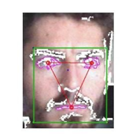
Figure 8 Facial Recognition Process (Image name below center Align , Bold Italic )

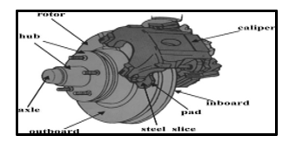
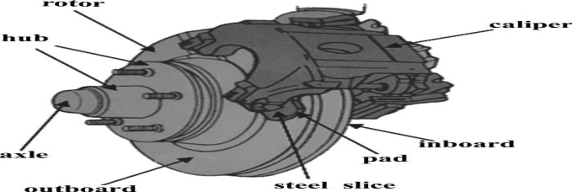
Results | Minimum | Maximum | Units | Reported Frequency (Hz)
Total Deformation1 | 0. | 26.403 | mm | 532.39
Total Deformation2 | 0. | 26.435 | mm | 534.09
Total Deformation3 | 0. | 18.595 | mm | 782.16
Total Deformation4 | 0. | 17.531 | mm | 1081.7
Total Deformation5 | 0. | 28.835 | mm | 1099.3
Total Deformation6 | 0. | 28.82 | mm | 1099.4
Total Deformation7 | 0. | 31.12 | mm | 2594.1
Total Deformation8 | 0. | 31.348 | mm | 2604.6
(Table name center Align , Bold Italic)

RESULTS AND DISCUSSION Font Size 10, Times New Roman
Service Delivery System is a major indicator towards achieving Health for All. However, there are several factors affecting health care service delivery system in Jose Abad Santos considering that it is classified as GIDA (Geographically Isolated and Depressed Area). These are the following:
Geographical Situation. Certain barangays are far from the Municipal Health Center. It has poor to no means of transportation and communication that can be worsened by sudden changes of weather.

ACKNOWLEDGEMENT Font Size 10, Times New Roman
We thank the staff and our colleagues from the Rural Heath Unit of Jose Abad Santos, Davao Occidental, Philippines, headed by the Municipal Health Officer, Dr. Amparo A. Lachica, who provided insight and expertise that greatly assisted the research. We thank the Graduate School of Government and Management, University of Southeastern Philippines for assistance and for comments that greatly improved the manuscript. We are expressing our gratitude to our families for being an inspiration. Above all, to God.

CONCLUSION Font Size 10, Times New Roman
Based on the Philippine Health Agenda Framework, the study concluded that the Rural Health Unit under the Local Government Unit of Jose Abad Santos has gaps in terms of health care delivery system. To achieve the Agenda goals, a service delivery network and universal health insurance are a must. Strategies include an increased health service coverage in family health, infectious, non- communicable and environmental health care services; Improved Service Delivery Capacity of frontline Health Care Providers; Enhanced Logistics Management System (Supply Chain Management) at the Provincial Health Office and Rural Health Unit to ensure that medicines and other commodities are available all the time; Enhanced timely and reliable Health Information System.

REFERENCES Font Size 10, Times New Roman
- Department of Health, Philippines. Responsible Parenthood and Reproductive Health Law.
- Department of Health, Philippines. The Philippine Health System at a Glance. Retrieved from https://www.doh.gov.ph/sites/default/files/basic-page/chapter-one.pdf
- Hodge, A., Firth, S., Bermejo III, R., Zeck, W., Soto, E.J. (2016). BMC Public Health. Utilisation of health services and the poor: deconstructing wealth-based differences in facility-based delivery in the Philipines.2016.
- Institute of Medicine (US) Committee on Assuring the Health of the Pubic in the 21st Century (2002). The Future of the Public’s Health in the 21st Century. Retrieved from https://www.ncbi.nlm.nih.gov/books/NBK221227/?fbclid=IwAR3BjZTRGwZaR1Nd_to3IzWsbH33qO7fziaiJoFDIz-jZn8Ir4P4S2_67Q0
- Local Government of Jose Abad Santos, Philippines. Scorecard 2017-2018.
- Local Government of Jose Abad Santos, Philippines. Regional Health Information System 2017-2018.
- Romuladez, A. G., Dela Rosa, J.F.E., Flavier, J.D.A., Quimbo, S.L.A., Hartigan-Go, K.Y., Lagrada, L.P., David, L.C., Department of Health (2011). The Philippines Health Review. Health Systems in Transition, Vol. 1 No.2.
- Rosell- Ubia, P.J.B., Department of Health Philippines (2016). All for Health Towards Health For All. Philippine Health Agenda 2016-2022.
- The Manila Times (2018, April 26). At a glance: The Philippine Health Care System

